## TOPS Technologies Logo

**NAME : DHAIRYA THAKKAR**

**ASSIGNMENT : Module 1**

**Faculty : Chinmayee Mam**

**1)What is software? What is software engineering ?**

🡪 Software is set of instruction executed by any kind of tool.

Software engineering

🡪 Use of engineering principle for developing software.

**2)Explain type of software.**

**🡪** SYSTEM SOFTWARE :-

Eg : Calculator ,notepad, clock

🡪APPLICATION SOFTWARE :-

Eg: Whatsapp , Instagram , LinkedIN , Twitter , Zoom,

* DRIVER SOFTWARE :-

🡪MIDDLEWARE:-

🡪PROGRAMMING SOFTWARE (Compiler , interpreter ):-

**3)What is SDLC? Explain each phase of SDLC**

* The Software Development Life Cycle (SDLC) refers to a methodology with clearly defined processes for creating high-quality software.

Each phase of SDLC :-

* Requirement Gathering
* Analysis
* Designing
* Implementation
* Testing
* Maintenance

Planning :- It involves collecting, analyzing, and documenting the needs and expectations of stakeholders to ensure that a project delivers what is actually needed.

information into smaller, more manageable parts to gain insights, solve problems, or make informed decisions.

Designing :- Designing is the process of creating and planning how something will look, function, and be structured.

Implementation :- Implementation is the process of putting a plan, design, or idea into action. It involves executing the steps necessary to bring a project or system from concept to reality.

Testing :- Testing is the process of evaluating a product, system, or component to ensure it meets the required standards and functions correctly

Maintenance :- Maintenance refers to the ongoing activities and processes involved in keeping a system, product, or infrastructure functioning effectively and efficiently throughout its lifecycle

1. **What is DFD ? Create a DFD diagram on Flipkart**

* DFD is the abbreviation for Data Flow Diagram.The Flow of data of a system or a process is represented by DFD .It also gives insight into the inputs and outputs of each entity and the process itself. DFD does not have control flow and no loops or decision rules are present . Specific operations depending on the type of data can be explained by flowchart. It is graphical tool. useful for communicating with users ,managers and other personnel. It is useful for analyzing existing as well as proposed system.

It provides an overview of

. What data is system processes.

.What transformation are performed .

.What data are stored.

.What results are produced . etc.

DFD diagram on flipkart

1. Level 0 DFD2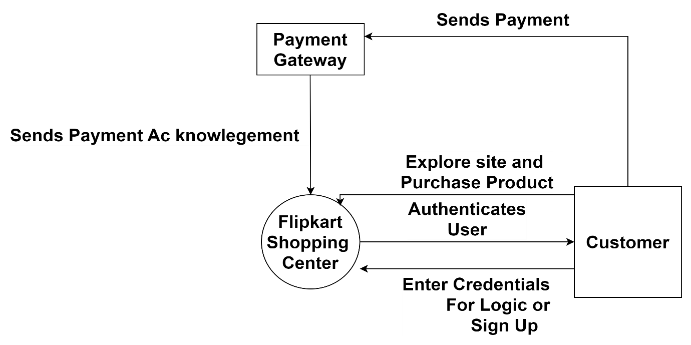
2. Level 1 DFD

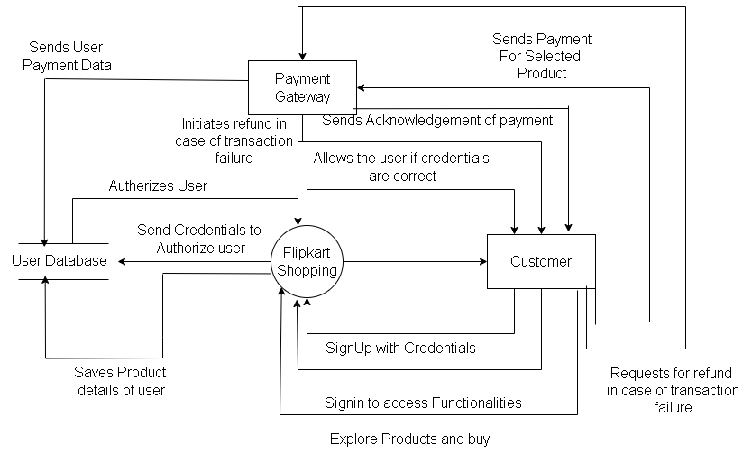

1. Level 2 DFD
2. Login

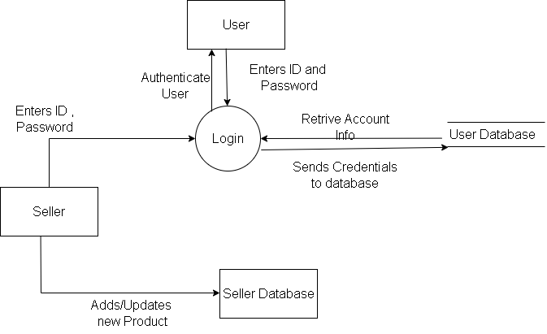

1. Sign Up

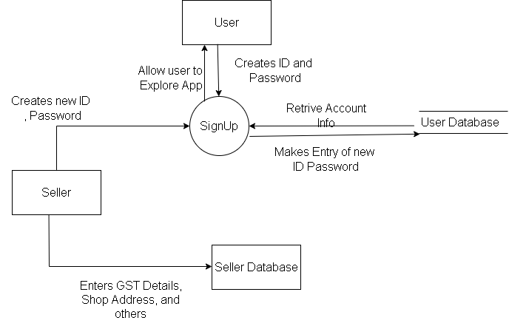

1. Payment Process

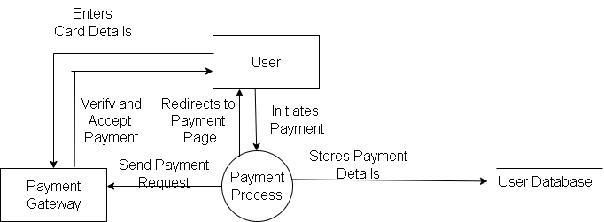

1. **What is flow chart? Create a flowchart to make addition of two numbers**

* A Flowchart is a type of diagram that represents a workflow or process . A flowchart can also be defined as a diagrammatic representation of an algorithm, a step- by step approach to solving a task.
* A Flowchart (or flow chart) is a diagram that shows the steps in a process.
* Flowcharts are often used for visualizing the sequence of actions or information needed for training,documenting, planning, and decision-making.
* They often use symbols, shapes, and arrows to illustrate how one step leads to another.

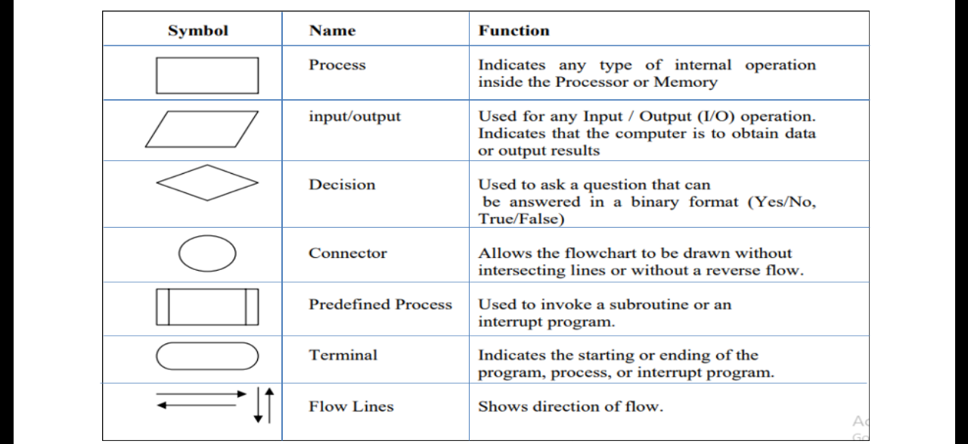

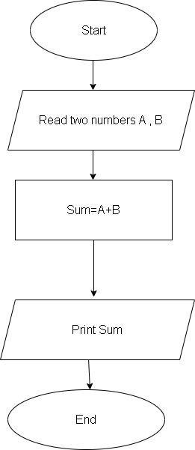

1. **What is Use case Diagram? Create a use-case on bill payment on paytm.**

* A use case is a written description of how users will perform tasks on your website. It outlines, from a user's point of view, a system's behavior as it responds to a request. Each use case is represented as a sequence of simple steps, beginning with a user's goal and ending when that goal is fulfilled.

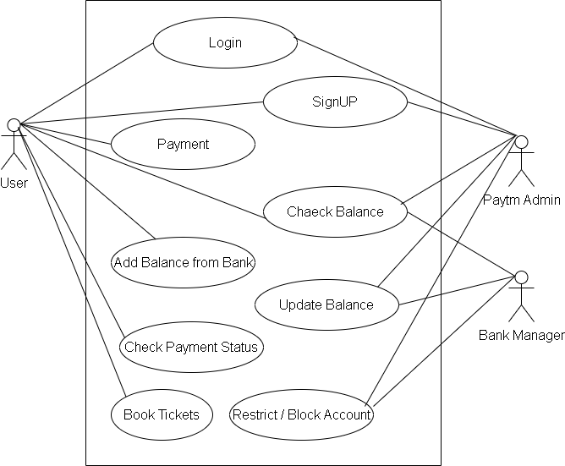

Top of Form